**School of Computing**

**ST0503 Back End Web Development**

**Chapter 5**

**Restful Web Services with MySQL (Model)**

**Objectives:**

After completing this lab, you should be able to:

* Create Web Service API
* Create model layer for backend
* Integrate Web service with MySQL database data

## Table of Contents

1. Initialising Node.js project
2. Installing the mysql npm package
3. Writing “models” for interacting with the database.

# 1. Initialising Node.js project

In this section, we will be initializing a Node.js project (called friendbook) that will be used for the remaining practicals.

Open the Command Prompt and create a folder named “friendbook” on your Desktop:

>>> cd Desktop/  
>>> mkdir friendbook  
>>> cd friendbook

Your command line should look like this:

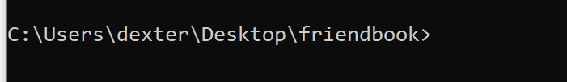

Setup npm with npm init:

>>> npm init

Hit Enter multiple times to use the default settings. Once that is done you should see a package.json file in the project folder.

Create the server.js file in the root directory with the following inside:

console.log("Hello world!");

Run the server.js file and you should see Hello world! printed on the terminal:

>>> node server.js  
Hello world!

# 2. Installing the mysql npm package

We will now connect to the MySQL server from our Node.js program so that we can consume data from the database. In Practical 6, we will serve the data to users of our API.

Install the mysql npm package with npm install:

>>> npm install --save mysql

Create a folder named db in the project root with an databaseConfig.js file inside.

**Project Structure**

models  
 databaseConfig.js  
server.js  
package.json  
package-lock.json

## Connecting to the MySQL Server

Import the mysql library in databaseConfig.js:

const mysql = require("mysql");

According to the mysql documentation, mysql.createConnection(options) and connection.connect() are used to connect to the database.

https://github.com/mysqljs/mysql/#establishing-connections

var dbconnect = {

getConnection: function () {

var conn = mysql.createConnection({

host: 'localhost',

port: 3306,

user: 'root',

password: 'password', //your own password

database: 'friendbook',

dateStrings: true

});

return conn;

}

};

// put this at the end of the file  
module.exports = dbconnect;

# 3. Writing “models” for interacting with the database.

A database model contains methods that interact with the database.

We will now create models that will be exclusively used to interact with the database when the REST server is implemented in Practical 4.

The User model will contain the following methods:

User.findByID(id, callback)  
User.findAll(callback)  
User.insert(user, callback)  
User.edit(userID, user, callback)  
User.delete(userID, callback)  
User.addFriend(userIDOne, userIDTwo, callback)  
User.removeFriend(userIDOne, userIDTwo, callback)  
User.showFriends(userID, callback)

Create a folder in the project root named models.

Create a file named User.js inside the models folder.

**Project Structure**

models  
 databaseConfig.js  
 User.js  
server.js  
package.json  
package-lock.json

### 3.1. Creating the User model

Add the following to the models/User.js file:

// we can rename connection as db or anything we choose.  
const db = require("./databaseConfig");  
  
const User = {  
  
};  
  
module.exports = User;

We export the User object so that we can use it when we create our REST API in Practical 4.

### 3.2. Implementing the User.findByID() method

We can store functions in the property of an object literal as functions are objects in JavaScript.

We’ll now implement the User.findByID(id, callback) method:

const User = {

findByID: function(userID, callback) {

var dbConn = db.getConnection();

dbConn.connect(function (err) {

if (err) {//database connection gt issue!

console.log(err);

return callback(err, null);

} else {

// We can use "?" as placeholder for user provided data.  
 // The userID is passed in through the second parameter of the query

// method.  
 // This is done instead of using string templates to prevent SQL

// injections.  
 // https://github.com/mysqljs/mysql#escaping-query-values

const findUserByIDQuery = "SELECT * FROM user WHERE id = ?;";

dbConn.query(findUserByIDQuery, [userID], (error, results) => {

dbConn.end();

if (error) {

return callback(error, null);

};

console.log(results);

return callback(null, results);

});

}

});

}

}

Import the User model from the main server.js and test out the User.findByID() method:

const User = require("./models/User");  
  
User.findByID(1, (error, user) => {  
 if (error) {  
 console.log(error);  
 return;  
 };  
 console.log(user);  
});

Kill the server with CTRL-C. Start the server again. You should see a list of one user printed:

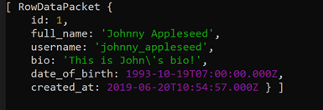

We only want the first element of the array, not the array itself. Modify the User.findByID() method:

Return callback(null, results[0]);

instead of

return callback(null,results);

Restart the server again. You should only see the object without the array:

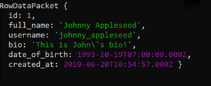

What happens if there are no users with the id passed in?

Change the userID passed in to a non-existing id:

User.findByID(1000);

You should see undefined printed out.

This is because results is an empty array. Accessing a non-existing server will return undefined.

Let’s propagate the user information and potential errors by calling the callback function passed in. We want null to be propagated when there are no users found instead of undefined.

Modify User.findByID() accordingly similar to below:

// callback signatures are usually (error, value)  
findByID: function(userID, callback) {

…  
 if (results.length === 0) {  
 callback(null, null);  
 return;  
 };  
 …  
}

Update the method call from the root server.js to pass in a callback:

User.findByID(100, (error, user) => {  
 if (error) {  
 console.log(error);  
 return;  
 };  
 console.log(user);  
});

You should see null printed.

Pass in a valid user id of 1. You should see the user object printed:

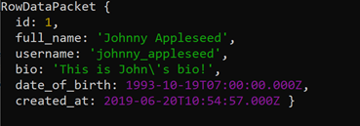

### 3.3. Implementing the User.findAll() method

Let’s implement the User.findAll(callback) method. It should query for all users in the database and pass it to the callback function.

Add the findAll() method to the User object:

findAll: function(callback) {

...

//add in connection related code…

const findAllUsersQuery = "SELECT * FROM user;";  
 dbConn.query(findAllUsersQuery, (error, results) => {  
 if (error) {  
 return callback(error, null);  
   
 };

return callback(null, results);  
 });

…  
}

Call the User.findAll() method in the main server.js:

const User = require("./models/User");  
  
User.findAll((error, users) => {  
 if (error) {  
 console.log(error);  
 return;  
 }  
 console.log(users);  
});

Kill and start the server. You should see the following output:

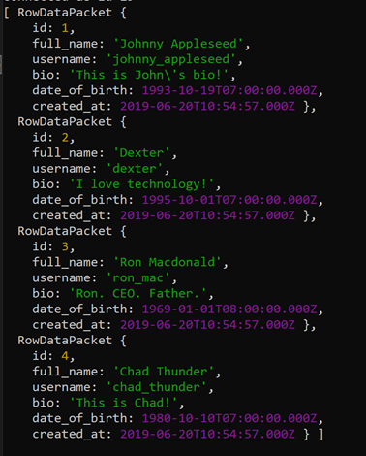

### 3.4. Implementing the User.insert() method

We’ll now implement the User.insert(user, callback) method. The callback function will have a signature of (error, userID).

The user object should not provide an id because the id is autogenerated by the database.

Add the insert() method to the User object:

insert: function(user, callback) {

...

//add in connection related code…

const insertUserQuery =  
 `  
 INSERT INTO user (username, full_name, bio, date_of_birth)  
 VALUES (?, ?, ?, ?);  
 `;  
 dbConn.query(  
 insertUserQuery,  
 [user.username, user.full_name, user.bio, user.date_of_birth],  
 (error, results) => {

dbConn.end();  
 if (error) {  
 return callback(error, null);  
   
 };  
 return callback(null, results.insertId);  
 });

…  
 },

Test out the method in the main server.js:

const User = require("./models/User");  
  
// We don't need to provide the id because it is generated by the database.  
const user = {  
 username: "julius",  
 full_name: "Julius",  
 bio: "Software engineer at Boogle",  
 date_of_birth: "2001-10-16"  
};  
  
User.insert(user, (error, userID) => {  
 if (error) {  
 console.log(error);  
 return;  
 };  
 console.log(userID);  
});

Run the server again and you should see the user id printed:

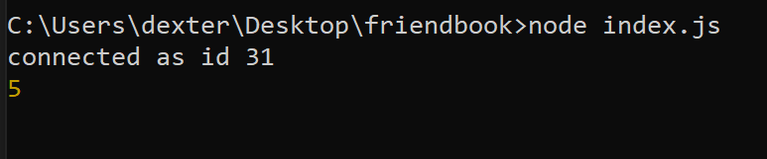

Note that the id maybe different for you as it depends on the no. of previous users created.

### 3.5. Implementing the User.edit() method

Now let’s implement the User.edit(userID, user, callback) method. The callback would just be (error). The lack of error would indicate that the user’s information has successfully been edited.

Add the edit method to the User model object:

edit: function(userID, user, callback) {

...

//add in connection related code…

const editUserQuery =  
 `  
 UPDATE user  
 SET  
 full_name = ?,  
 username = ?,  
 bio = ?,  
 date_of_birth = ?  
 WHERE id = ?  
 `;  
 dbConn.query(editUserQuery, [user.full_name, user.username, user.bio, user.date_of_birth, userID], (error, results) => {  
 dbConn.end();

if (error) {  
 return callback(error);  
   
 };  
 return callback(null);  
 });

…  
 };

Test out the method in the main server.js:

const User = require("./models/User");  
  
const editedUser = {  
 full_name: "Julius Lim",  
 username: "julius",  
 bio: "Software engineer at Boogle",  
 date_of_birth: "2001-10-16"  
};  
  
// provide the user id of the user with full_name "Julius"  
// it may not be 5 for you  
User.edit(5, editedUser, (error) => {  
 if (error) {  
 console.log(error);  
 return;  
 };  
});

Kill and start the server. Inspect the user table in MySQLWorkbench. You should see a user with full_name of “Julius Lim”.

### 3.6. Exercise: Implementing the rest of the User model

Implement the delete and addFriend methods with the following signatures:

User.addFriend(userIDOne, userIDTwo, (error))  
User.removeFriend(userIDOne, userIDTwo, (error))  
User.showFriends(userID, (error, friends))

Refer to Practical 2 for the SQL queries.

### 3.7. Implementing the Post model.

Create a file named Post.js under the models folder.

Paste this in:

const db = require("./databaseConfig.js");

const Post = {

// propagates a list of posts posted by a user

// each post contains a "likers" property, which contains an array of users that liked the post.

findByUserID: function (userID, callback) {

var dbConn = db.getConnection();

dbConn.connect(function (err) {

if (err) {//database connection gt issue!

console.log(err);

return callback(err, null);

} else {

const findByUserIDQuery =

`

SELECT * FROM post

WHERE fk_poster_id = ?

ORDER BY created_at DESC;

`;

dbConn.query(findByUserIDQuery, userID, (error, posts) => {

dbConn.end();

if (error) {

return callback(error, null);

}

const postIDs = posts.map(post => post.id);

//creates a new array with the post id

Post.findLikersByPostIDs(postIDs, (error, likersByPostID) => {

//likersByPostID is a map containing the postids-> likers’ userid

if (error) {

return callback(error, null);

}

//transfer the likers’ userid to the respective posts with a new

//attribute in posts called likers

for (let i = 0; i < posts.length; i++) {

posts[i].likers = likersByPostID[posts[i].id];

}

return callback(null, posts);

});

});

}

});

},

findByID: function (postID, callback) {

var dbConn = db.getConnection();

dbConn.connect(function (err) {

if (err) {//database connection gt issue!

console.log(err);

return callback(err, null);

} else {

const findByIDQuery =

`

SELECT * FROM post

WHERE id = ?;

`;

dbConn.query(findByIDQuery, postID, (error, results) => {

dbConn.end();

if (error) {

return callback(error, null);

}

if (results.length === 0) {

return callback(null, null);

}

return callback(null, results[0]);

});

}

});

},

findAll: function (callback) {

var dbConn = db.getConnection();

dbConn.connect(function (err) {

if (err) {//database connection gt issue!

console.log(err);

return callback(err, null);

} else {

const findAllQuery =

`

SELECT * FROM post;

`;

dbConn.query(findAllQuery, (error, results) => {

dbConn.end();

if (error) {

return callback(error, null);

}

return callback(null, results);

});

}

});

},

insert: function (post, callback) {

var dbConn = db.getConnection();

dbConn.connect(function (err) {

if (err) {//database connection gt issue!

console.log(err);

return callback(err, null);

} else {

const insertQuery =

`

INSERT INTO post (text_body, fk_poster_id)

VALUES

(?, ?);

`;

dbConn.query(insertQuery, [post.text_body, post.fk_poster_id], (error, results) => {

dbConn.end()

if (error) {

return callback(error, null);

}

return callback(null, results.insertId);

});

}

});

},

edit: function (postID, post, callback) {

var dbConn = db.getConnection();

dbConn.connect(function (err) {

if (err) {//database connection gt issue!

console.log(err);

return callback(err, null);

} else {

const editPostQuery =

`

UPDATE post

SET

text_body = ?

WHERE id = ?;

`;

dbConn.query(editPostQuery, [post.text_body, postID], (error, results) => {

if (error) {

return callback(error);

};

return callback(null);

});

}

});

},

delete: function (postID, callback) {

var dbConn = db.getConnection();

dbConn.connect(function (err) {

if (err) {//database connection gt issue!

console.log(err);

return callback(err, null);

} else {

const deletePostQuery =

`

DELETE FROM post

WHERE id = ?

`;

dbConn.query(deletePostQuery, postID, (error, results) => {

dbConn.end();

if (error) {

return callback(error);

};

return callback(null);

});

}

});

},

like: function (postID, likerID, callback) {

var dbConn = db.getConnection();

dbConn.connect(function (err) {

if (err) {//database connection gt issue!

console.log(err);

return callback(err, null);

} else {

const likeQuery =

`

INSERT INTO likes

(fk_user_id, fk_post_id)

VALUES

(?, ?);

`;

dbConn.query(likeQuery, [likerID, postID], (error, results) => {

dbConn.end();

if (error) {

return callback(error);

}

return callback(null);

});

}

});

},

unlike: function (postID, likerID, callback) {

var dbConn = db.getConnection();

dbConn.connect(function (err) {

if (err) {//database connection gt issue!

console.log(err);

return callback(err, null);

} else {

const likeQuery =

`

DELETE FROM likes

WHERE

fk_user_id = ?

AND

fk_post_id = ?;

`;

dbConn.query(likeQuery, [likerID, postID], (error, results) => {

if (error) {

return callback(error);

}

return callback(null);

});

}

});

},

findLikers: function (postID, callback) {

var dbConn = db.getConnection();

dbConn.connect(function (err) {

if (err) {//database connection gt issue!

console.log(err);

return callback(err, null);

} else {

const findLikersQuery =

`

SELECT user.* FROM user, likes

where likes.fk_user_id = user.id

and likes.fk_post_id = ?

`;

dbConn.query(findLikersQuery, postID, (error, results) => {

dbConn.end();

if (error) {

callback(error, null);

return;

}

return callback(null, results);

});

}

});

},

// returns a object that maps post id to an array of likers of that post

findLikersByPostIDs: function (postIDs, callback) {

// we have to manually handle this edge case because

// mysql doesn't allow empty lists.

if (postIDs.length === 0) {

process.nextTick(() => {

return callback(null, {});

});

}

var dbConn = db.getConnection();

dbConn.connect(function (err) {

if (err) {//database connection gt issue!

console.log(err);

return callback(err, null);

} else {

const findLikersQuery =

`

SELECT user.*, likes.fk_post_id FROM user

Where likes.fk_user_id = user.id

and likes.fk_post_id IN (?);

`;

dbConn.query(findLikersQuery, [postIDs], (error, likers) => {

dbConn.end();

if (error) {

return callback(error, null);

}

const likersByPostID = {};

// initialize all post ids keys with an empty array

for (let i = 0; i < postIDs.length; i++) {

const postID = postIDs[i];

likersByPostID[postID] = [];

}

for (let i = 0; i < likers.length; i++) {

const liker = likers[i];

likersByPostID[liker.fk_post_id].push(liker);

}

return callback(null, likersByPostID);

});

}

});

}

}

module.exports = Post;

# Conclusion

Now that we are able to consume data from MySQL through Node.js code, we will create a REST API that allows a client to interact with our database through the internet.